7.2.2.4 Packet Tracer – Configuring Basic EIGRP with IPv4
Addressing Table
Device | Interface | IP Address | Subnet Mask | Default Gateway
R1 | G0/0 | 172.16.1.1 | 255.255.255.0 | N/A
 | S0/0/0 | 172.16.3.1 | 255.255.255.252 | N/A
 | S0/0/1 | 192.168.10.5 | 255.255.255.252 | N/A
R2 | G0/0 | 172.16.2.1 | 255.255.255.0 | N/A
 | S0/0/0 | 172.16.3.2 | 255.255.255.252 | N/A
 | S0/0/1 | 192.168.10.9 | 255.255.255.252 | N/A
R3 | G0/0 | 192.168.1.1 | 255.255.255.0 | N/A
 | S0/0/0 | 192.168.10.6 | 255.255.255.252 | N/A
 | S0/0/1 | 192.168.10.10 | 255.255.255.252 | N/A
PC1 | NIC | 172.16.1.10 | 255.255.255.0 | 172.16.1.1
PC2 | NIC | 172.16.2.10 | 255.255.255.0 | 172.16.2.1
PC3 | NIC | 192.168.1.10 | 255.255.255.0 | 192.168.1.1

Objectives
- Part 1: Configure EIGRP
- Part 2: Verify EIGRP Routing

Background
In this activity, you will implement basic EIGRP configurations including network commands, passive interfaces and disabling automatic summarization. You will then verify your EIGRP configuration using a variety of show commands and testing end-to-end connectivity.

Part 1: Configure EIGRP

Step 1: Enable the EIGRP routing process.
Enable the EIGRP routing process on each router using AS number 1. The configuration for R1 is shown.
R1(config)# router eigrp 1
What is the range of numbers that can be used for AS numbers?

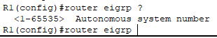
1 to 65535

Note: Packet Tracer currently does not support the configuration of an EIGRP router ID.

Step 2: Advertise directly connected networks.
- Use the show ip route command to display the directly connected networks on each router.

R1 | 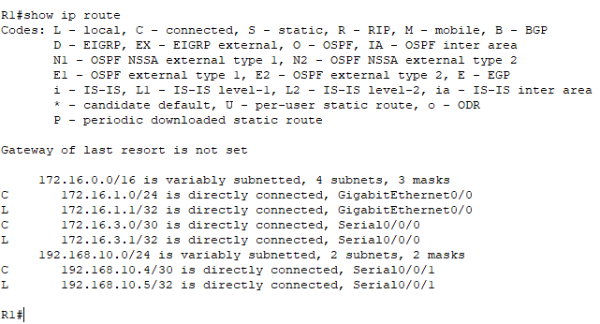
R2 | 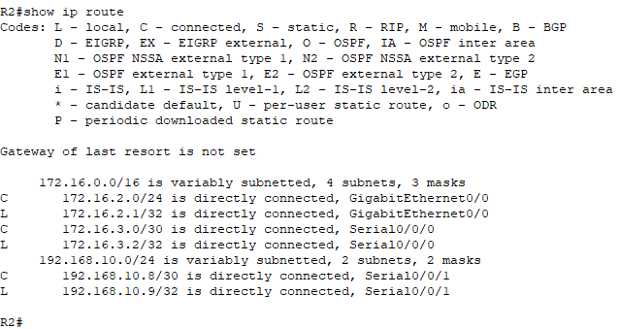
R3 | 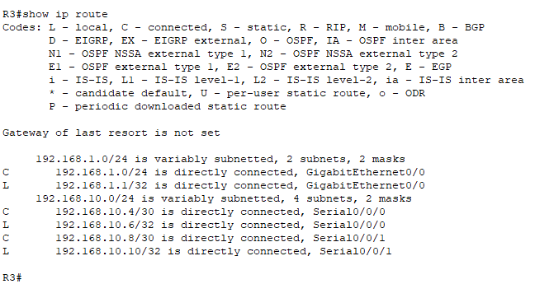

How can you tell the difference between subnet addresses and interface addresses?
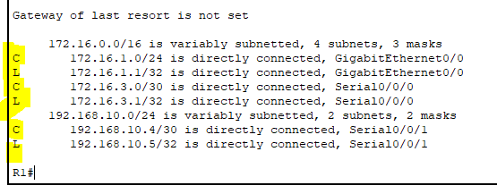
C is subnet address
L is interface address

- On each router, configure EIGRP to advertise the specific directly connected subnets. The configuration for R1 is shown.
R1(config-router)# network 172.16.1.0 0.0.0.255
R1(config-router)# network 172.16.3.0 0.0.0.3
R1(config-router)# network 192.168.10.4 0.0.0.3

R1 | 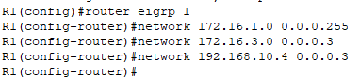  R1(config)#router eigrp 1  R1(config-router)#network 172.16.1.0 0.0.0.255  R1(config-router)#network 172.16.3.0 0.0.0.3  R1(config-router)#network 192.168.10.4 0.0.0.3
R2 | 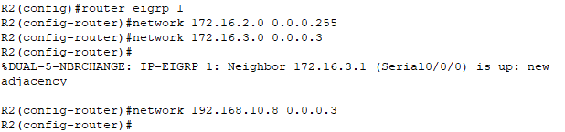  R2(config)#router eigrp 1  R2(config-router)#network 172.16.2.0 0.0.0.255  R2(config-router)#network 172.16.3.0 0.0.0.3  R2(config-router)#network 192.168.10.8 0.0.0.3
R3 | 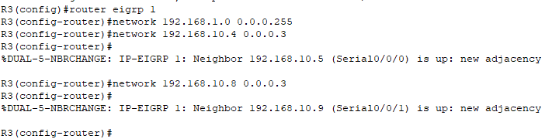  R3(config)#router eigrp 1  R3(config-router)#network 192.168.1.0 0.0.0.255  R3(config-router)#network 192.168.10.4 0.0.0.3  R3(config-router)#network 192.168.10.8 0.0.0.3

Step 3: Configure passive interfaces.
Configure the LAN interfaces to not advertise EIGRP updates. The configuration for R1 is shown.
R1(config-router)# passive-interface g0/0

Step 4: Disable automatic summarization.
The topology contains discontiguous networks. Therefore, disable automatic summarization on each router. The configuration for R1 is shown.
R1(config-router)# no auto-summary
Note: Prior to IOS 15 auto-summary had to be manually disabled.

Step 5: Save the configurations.

R1 | 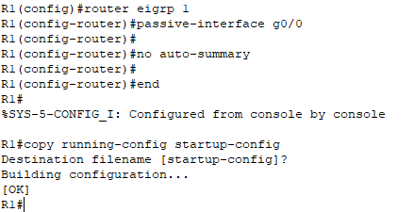
R2 | 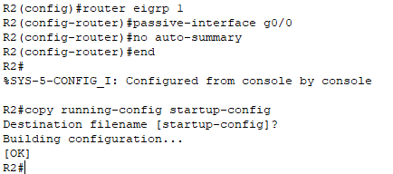
R3 | 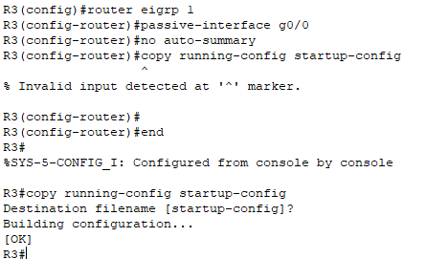

Part 2: Verify EIGRP Routing

Step 1: Examine neighbor adjacencies.
- Which command displays the neighbors discovered by EIGRP?

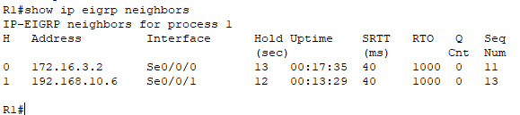
show ip EIGRP neighbors

- All three routers should have two neighbors listed. The output for R1 should look similar to the following:
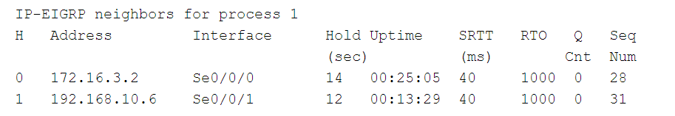

Step 2: Display the EIGRP routing protocol parameters.
- What command displays the parameters and other information about the current state of any active IPv4 routing protocol processes configured on the router?

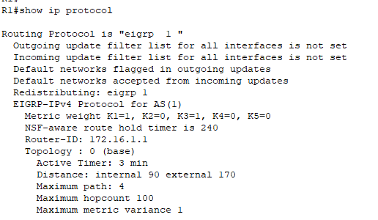
show ip protocol

- On R2, enter the command you listed for 2a and answer the following questions:
How many routers are sharing routing information with R2?

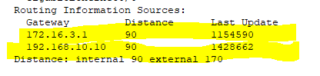
2 routers

Where is this information located under?

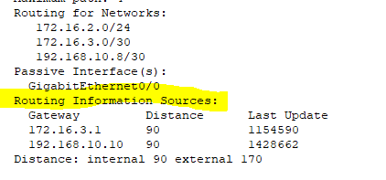
Routing Information Sources

What is the maximum hop count?

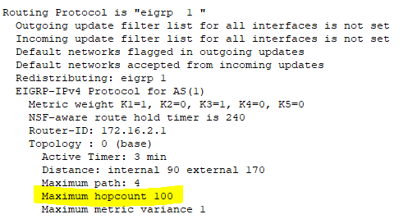
100

Step 3: Verify end-to-end connectivity
PC1, PC2 and PC3 should now be able to ping each other. If not, troubleshoot your EIGRP configurations.

PC1 ping PC2 | 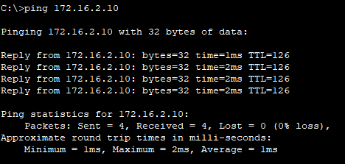  Successfully
PC1 ping PC3 | 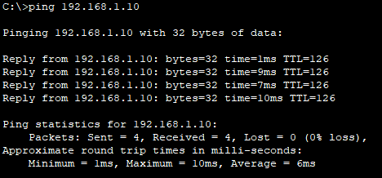  Successfully
PC2 ping PC3 | 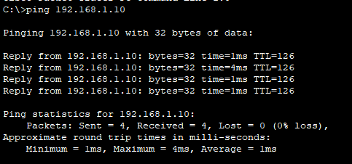  Successfully

